Project Plan: Cognitive Decline Risk Factory in the US Older Adults

Data:
The primary dataset used in this project is “Alzheimer’s Disease and Healthy Aging Data” from the Centers for Disease Control and Prevention, provided by the Behavioral Risk Factor Surveillance System (BRFSS): https://data.cdc.gov/Healthy-Aging/Alzheimer-s-Disease-and-Healthy-Aging-Data/hfr9-rurv/about_data
This dataset contains survey-based, state-level health data for adults aged 45 and older across the United States from 2015 to 2022. It includes approximately 284,000 rows and 31 columns.
It includes measures of subjective cognitive decline (SCD), mental health, physical health, and behavioral risk factors. Key variables include:
Key variables include cognitive decline indicators (e.g., memory loss affecting daily activities), depression, mental distress, physical inactivity, self-reported health status, disability, and demographic stratifications (age group and gender).
A complementary dataset from the U.S. Census Bureau (American Community Survey) will be used to provide state-level socioeconomic variables—using state as the common key—including median household income, educational attainment, and race.
Research Goal:
To analyze how health, behavioral, and socioeconomic factors influence cognitive decline among older adults across U.S. states, examine whether factors such as depression, physical inactivity, poor self-reported health, income, and education are key predictors, and provide insights for policymakers to identify high-risk populations and guide interventions.
Research Questions:
1. Which states have the highest levels of cognitive decline?
Method: Choropleth map (Tableau)
2. Is there a relationship between depression and cognitive decline?
Method: Correlation + scatter plot
3. Does physical inactivity correlate with cognitive decline?
Method: Correlation analysis
4. How does poor self-reported health relate to cognitive decline?
Method: Correlation + visualization
5. Is cognitive decline associated with disability rates?
Method: Correlation matrix
6. Does median household income relate to cognitive decline across states?
Method: Scatter plot + correlation
7. Does higher educational attainment reduce cognitive decline?
Method: Scatter plot + correlation
8. Does age structure (% population 65+) explain variation in cognitive decline?
Method: Regression + correlation
9. Are early-stage memory complaints strongly associated with severe cognitive decline?
Method: Correlation comparison (early vs severe variables)
10. Which combination of health and socioeconomic variables best predicts cognitive decline?
Method: Multiple linear regression
Tools:
- Python (Pandas, NumPy, Seaborn & Matplotlib, Scikit-learn): Data cleaning, transformation, exploratory data analysis, visualization, and regression modeling
- Tableau: Interactive dashboard and choropleth map visualization
- Jupyter Notebook: Analysis workflow and documentation
- SQLite and R, depending on the need
Methods:
Descriptive (EDA, visualization) and predictive modeling (regression analysis):
- Data cleaning and filtering
- Pivot tables for restructuring long-format data
- Correlation analysis
- Visualization
- Regression modeling
- Geographic visualization using maps
Resources:
- CDC documentation, U.S. Census, Course materials (CRISP-DM framework)

Risks and Mitigations

Some variables have missing values due to optional survey modules.

Mitigation: remove the rows that are missing the essential measurement factors
- Self-Reported Bias: Responses may not be fully accurate.
Mitigation: Acknowledge as a limitation in interpretation.
- Aggregation Bias: State-level data cannot represent individual behavior.
Mitigation: Frame conclusions at the population level only.
- Weak or Spurious Correlations: Some variables appear related but not causally linked.
Mitigation: Use multiple variables and domain knowledge.
- Some cognitive decline variables are not reported for all states and years due to optional BRFSS survey modules.
Mitigation: Restrict analysis to observations where the target variable is available and clearly report reduced sample size.

Milestones

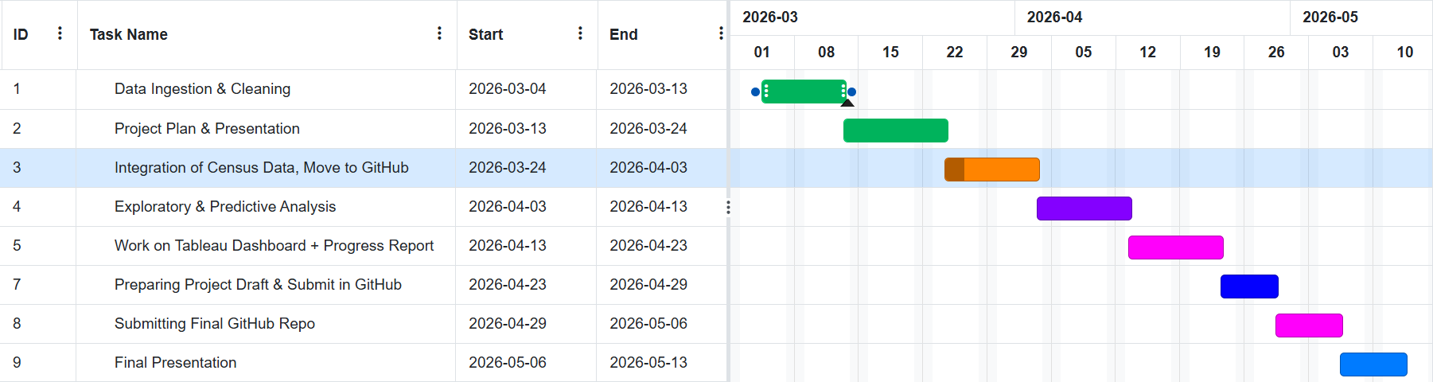
Dependencies:
Later stages (modeling and visualization) depend on successful cleaning, variable selection, and handling of missing data.
Minimum Viable Product (MVP):
A cleaned dataset, 2–3 strong visualizations, and basic correlation analysis answering key research questions. My stretch goal is to develop an interactive Tableau dashboard to visualize state-level cognitive decline and associated risk factors.

